**Lesson 17: Area and Degrees of a Circle**

**Do Now:**

1. A rectangle has a length of 9 inches and a width of 4 inches. Find the perimeter and area.
2. Find the area and perimeter of a square with each side measuring 5 inches.
3. A rectangle has an area of 56 square feet and a width of 4 feet. What is the length?
4. A rectangular yard has a length of 16 meters and a width of 3 meters. Find the area.
5. **Perimeter is 26 inches. Area is 36 inches squared.**
6. **Perimeter is 20 inches. Area is 25 inches squared.**
7. **14 feet.**
8. **48 meters squared.**

**Independent Practice:**

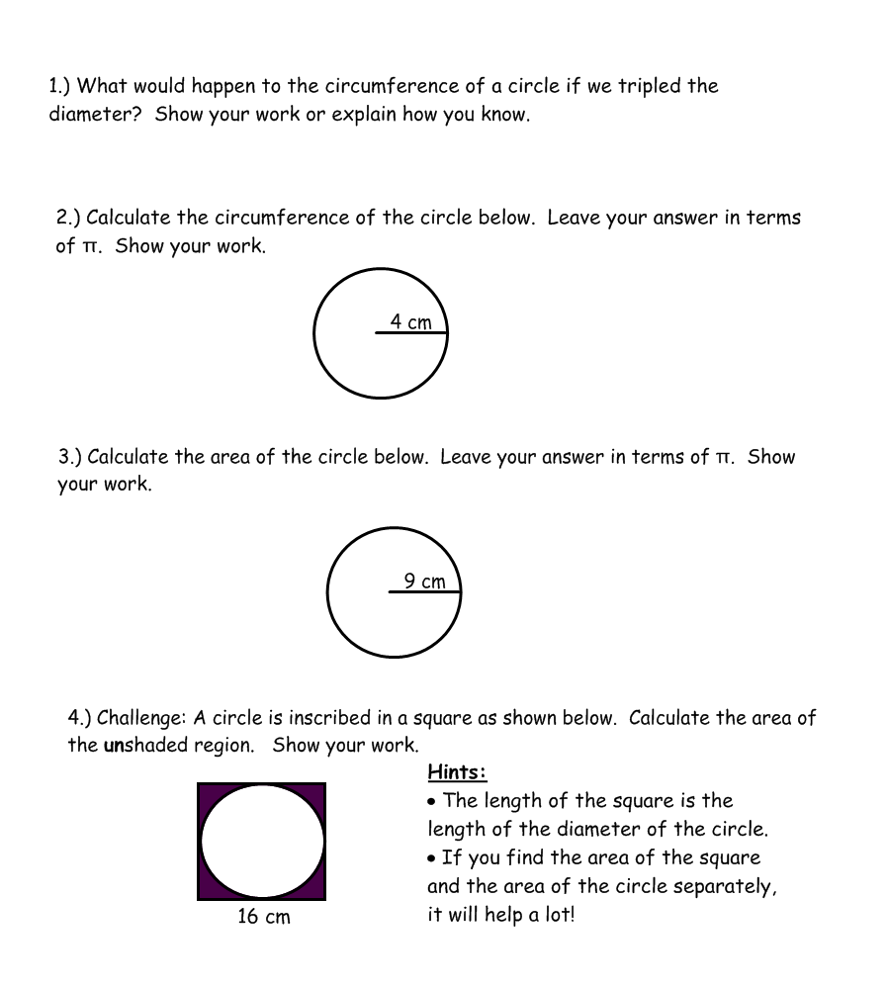

C = 2πr = πd

π(3d) = 3(πd). The circumference is also tripled.

C = 2πr = 2π(4 cm) = 8π cm

A = r2π = (9 cm)2π = 81 π cm2

Area of shaded region = Area of square (the whole figure) – Area of circle

= (16 cm)2 – (8 cm)2 π = 256 - 64 π cm2